**Assignment No 4**

**Shivam Navnath Giri**

**CDAC PGDAI SILCHAR**

**FOI**

**Q1 . Given the blocks world indicated in Fig. Solve using Global heuristic function**

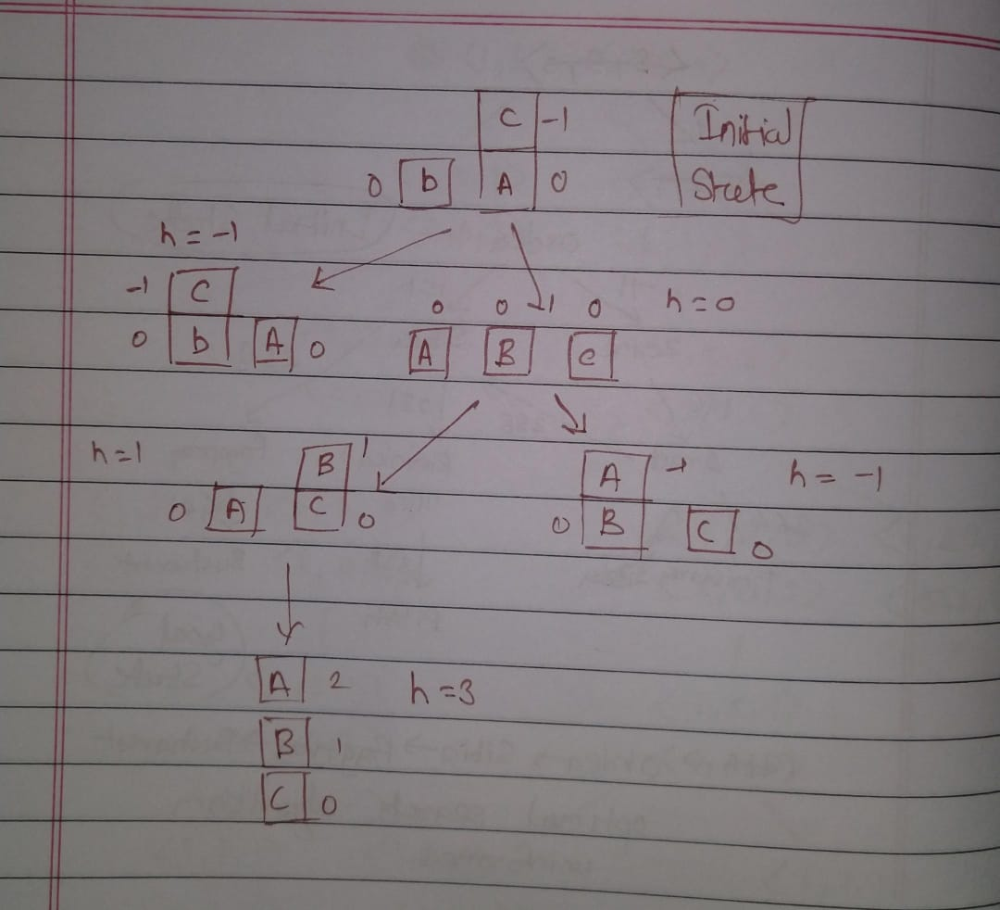

**Q2.Solve using A* Algorithm ()**

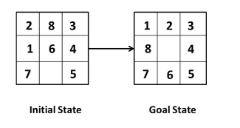

**Solution :**

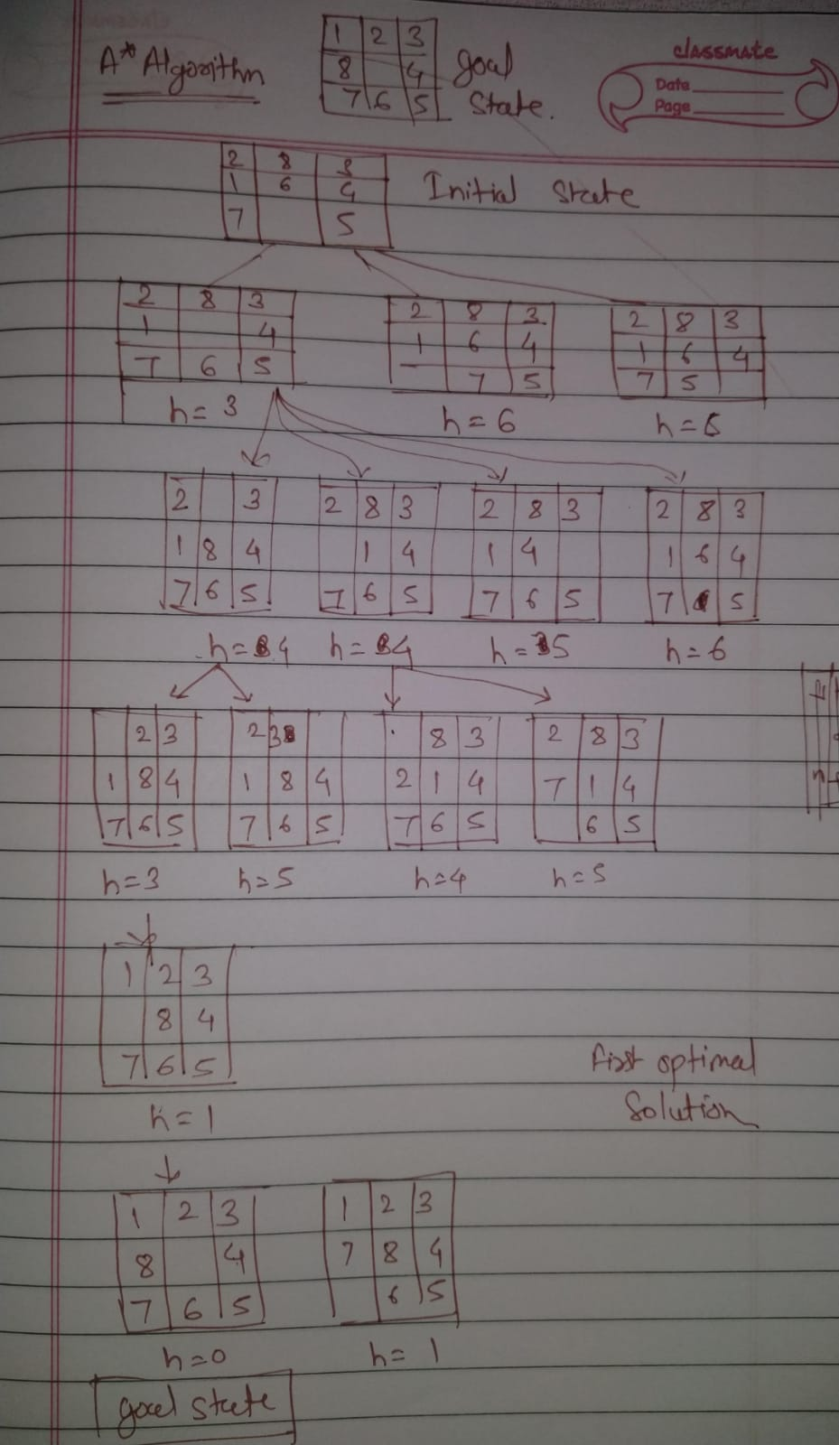

**Q3. The map of Romania is given. Start node is Arad and Goal node is Bucharest. Find the**

**optimal path using informed search algorithm.**

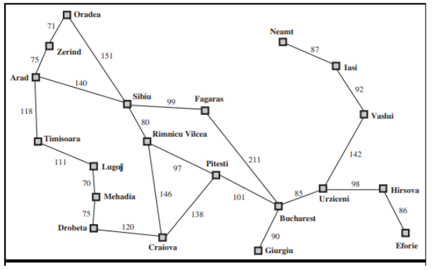

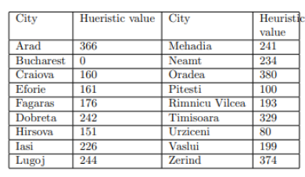

**Solution :**

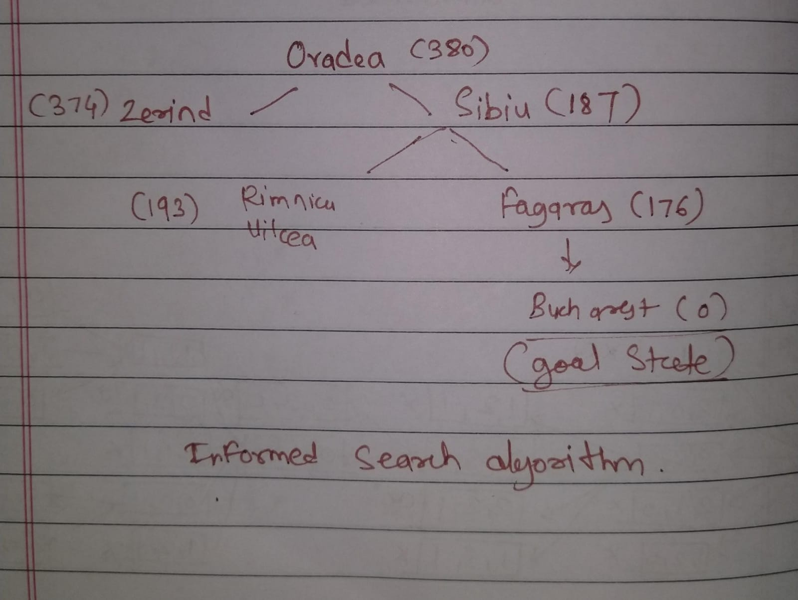

**Q4. Solve using hill climbing Algorithm**

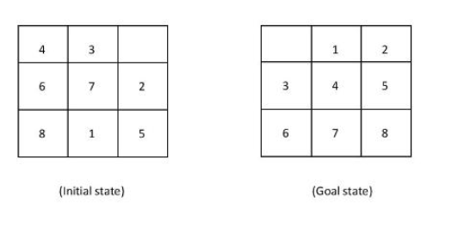

**Solution :**

